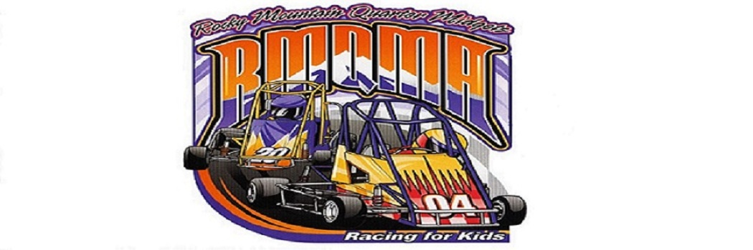

*ROCKY MOUNTAIN QUARTER MIDGET ASSOCIATION*

2018 Sponsorship Application

Get your Business or Organization recognized and help an exciting Youth Sports Program!

RMQMA is a non-profit organization (501c3) and all sponsorship programs are 100% tax deductible for 2018.

Sponsorship Information

Name: ___________________________________________________

Billing Address: ___________________________________________

City _______________________ State ________ Zip ____________

Email ____________________________________________________

Company Website __________________________________________

Sponsorship Levels

1. Annual sponsorship - $250

RMQMA will place Your Company’s Logo a on the Club website (under construction) and Facebook throughout the season until December 31, 2018. Your company’s logo will also be linked to your website from www.rmqma.com

1. Annual sponsorship *and* Trackside Banner - $500

You receive all the benefits of the annual sponsorship above, ***PLUS*** - **RMQMA will provide and place a 3’ x 5’ Banner with your company’s logo at our racing facility. It will be prominently displayed though-out the season until December 31, 2018.**

Annual sponsorship, Trackside Banner, *and* Division sponsor - $750



You receive all the benefits of the annual sponsorship above, Trackside Banner, ***PLUS*** – **You will get to pick a race division to be announced before, during and after the race on the PA system.**

RMQMA is a non-profit volunteer organization for kids ages 5-17. ALL proceeds will be used towards improving our racing program for the benefit of our kids!

**Visit our website** [**www.rmqma.com**](http://www.rmqma.com) **for race schedule and latest club information.**

**Questions: Club president Mike Hinds 303-903-8649**

Please make checks payable to: RMQMA Tax ID #84-0780183 *Thank You!*

*RMQMA Raceway* 5074 Summit Blvd Dacono, CO 80514